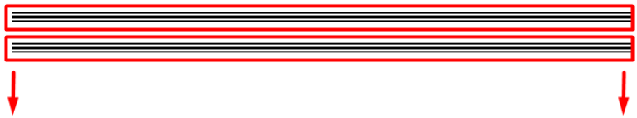

2

اظبط امكانيه اضافه منتج داخل قسم من خلال القسم نفسه

تمام عملتها كل الفكراه انى جبت ال id وحتيطه فى حقل مخفى وجبت فورم كامله بتعات انشاء منتج وفيها ال route...... والحقل المخفى فيه ال id بتع المنتج واسم الحقل بى اسم ال department_id

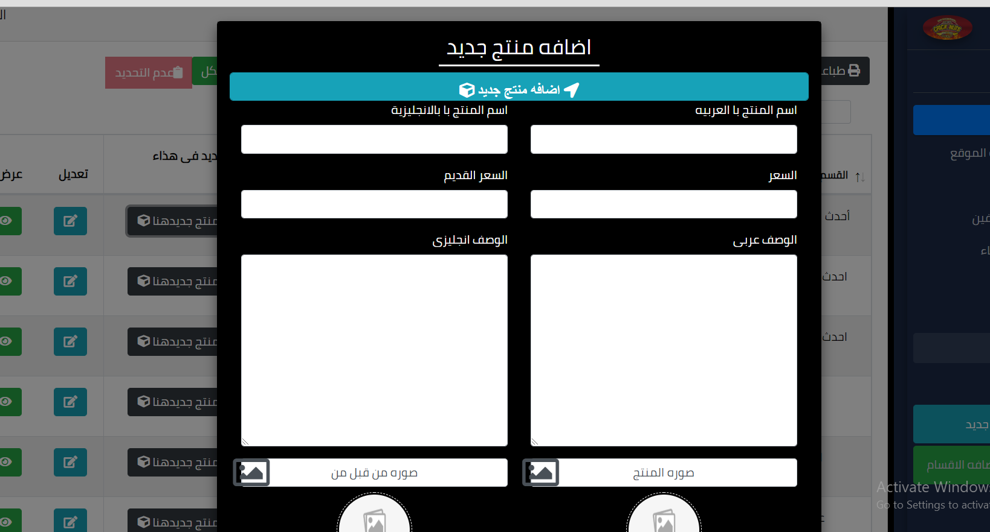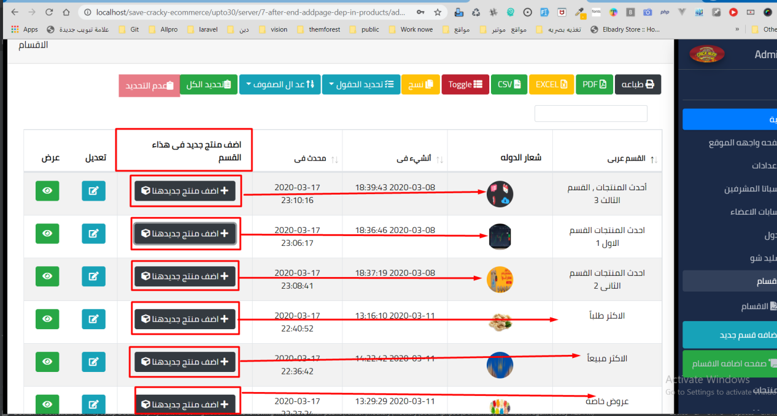

وذاى ما احنا متعودين ده الكود كامل

الview

{{--<a href="{{ aurl('departments/'.$id.'/edit') }}" class="btn btn-dark"><i class="fa fa-cube"></i></a>--}}  
  
 @push('js')  
 <script>  
 $(***document***).ready(function () {  
 $('#jstree').jstree({  
 'core' : {  
 'data' : {!! load_dep($parent,$id) !!},  
 "themes": {  
 "name": "default-dark",  
 "dots": true,  
 "variant": "large",  
 "icons": true,  
 "multiple" : true,  
 "animation" : 1000,  
 }  
 },  
 "checkbox" : {  
 "keep_selected_style" : false  
 },  
 "plugins" : [ "wholerow","radio","/*checkbox*/" ]  
 });//#jstree  
 });//document  
  
 //-----------------------get id  
 $('#jstree').on('changed.jstree',function(e,data){  
 var i , j , r =[];//= var i[]; var j[];var r[];  
 for(i=0,j = data.selected.length;i < j;i++ )  
 {  
 r.push(data.instance.get_node(data.selected[i]).id);  
 }//for  
 $('.parent_id').val(r.join(','));  
 //1,2,3,4,5,6  
 });/*changed*/  
  
 </script>  
 @endpush  
 <!-- Trigger the modal with a button -->  
  
  
<button type="button" class="btn btn-dark" data-toggle="modal" data-target="#add_product_departments{{ $id }}"><i class="fa fa-plus"> </i> {{ trans('admin.add_poroduct_in_this_dep') }}<i class="fa fa-cube"></i></button>  
<!-- Modal -->  
<div id="add_product_departments{{ $id }}" class="modal fade" role="dialog">  
 <div class="modal-dialog modal-lg">  
 <div class="modal-content">  
 <!-- start Modal lg---------------- -->  
 <div class="modal-body">  
 <div class="container-fluid">  
 {{-- -------------------------------------------------------}}  
 <div class="box">  
 <div class="box-header">  
 <center class="box-title"><h3 class="head_title">{{ trans('admin.create_new_product') }}</h3></center>  
 </div>  
 <section class="modal_massage"> @include('back.message_error') </section>  
 <!-- /.----------------------------------------------------------------- -->  
 <div class="box-body">  
 {!! Form::*open*(['url'=>aurl('products/create_quick'),'files'=>true]) !!}  
 {!! Form::*hidden*('department_id',$id,['class'=>'form-control' ]) !!}  
 <div class="row">  
 {{ Form::*button*('<i class="fa fa-location-arrow "> '  
 . trans('admin.create_new_product').'  
 </i> <i class="fas fa-cube"> </i> ' ,  
 ['type' => 'submit', 'class' => 'form-control btn btn-info btn-lg'] )  
 }}  
 <div class="col-md-6 content_form_ar" >  
 <div class="form-group">  
 {!! Form::*label*('product_name_ar',trans('admin.product_name_ar')) !!}  
 {!! Form::*text*('product_name_ar',old('product_name_ar'),['class'=>'form-control','class'=>'form-control' ]) !!}  
 </div><!-- /.form-group product_name_en -->  
 <div class="form-group">  
 {!! Form::*label*('price',trans('admin.price')) !!}  
 {!! Form::*text*('price',old('price'),['class'=>'form-control','class'=>'form-control' ]) !!}  
 </div><!-- /.form-group price -->  
 <div class="form-group">  
 {!! Form::*label*('description_ar',trans('admin.description_ar')) !!}  
 {!! Form::*textarea*('description_ar',old('description_ar'),['class'=>'form-control','class'=>'form-control' ]) !!}  
 </div><!-- /.form-group description_ar -->  
 <!----------------start photo-->  
 <div class="input-group ">  
 <div class="custom-file">  
 {!! Form::*label*('photo',trans('admin.photo_products'),['class'=>'custom-file-label']) !!}  
 {!! Form::*file*('photo',['class'=>'custom-file-input','id'=>'inputGroupFile02'] ) !!}  
 </div>  
 </div>  
 <div class="text-center"> <img src="{{url('default')}}/product.png" class="img_100px"></div>  
 <!----------------End photo-->  
 <div class="form-group">  
 {!! Form::*label*('price_offer',trans('admin.price_offer')) !!}  
 {!! Form::*text*('price_offer',old('price_offer'),['class'=>'form-control','class'=>'form-control' ]) !!}  
 </div><!-- /.form-group price_offer -->  
  
  
 <div class="form-group">  
 {!! Form::*label*('add_by_ar',trans('admin.add_by_ar')) !!}  
 {!! Form::*text*('add_by_ar',old('add_by_ar'),['class'=>'form-control','class'=>'form-control' ]) !!}  
 </div><!-- /.form-group add_by_ar -->  
  
 </div><!--col-md-6 content_form_ar-->  
 <div class="col-md-6 content_form_en" >  
 <div class="form-group">  
 {!! Form::*label*('product_name_en',trans('admin.product_name_en')) !!}  
 {!! Form::*text*('product_name_en',old('product_name_en'),['class'=>'form-control','class'=>'form-control' ]) !!}  
 </div><!-- /.form-group product_name_en -->  
 <div class="form-group">  
 {!! Form::*label*('price_old',trans('admin.price_old')) !!}  
 {!! Form::*text*('price_old',old('price_old'),['class'=>'form-control','class'=>'form-control' ]) !!}  
 </div><!-- /.form-group price_old -->  
  
 <div class="form-group">  
 {!! Form::*label*('description_en',trans('admin.description_en')) !!}  
 {!! Form::*textarea*('description_en',old('description_en'),['class'=>'form-control','class'=>'form-control' ]) !!}  
 </div><!-- /.form-group description_en -->  
 <!----------------start add_by_photo-->  
  
 <div class="input-group ">  
 <div class="custom-file">  
 {!! Form::*label*('add_by_photo',trans('admin.add_by_photo_products'),['class'=>'custom-file-label']) !!}  
 {!! Form::*file*('add_by_photo',['class'=>'custom-file-input','id'=>'inputGroupFile02'] ) !!}  
 </div>  
 </div>  
 <div class="text-center"> <img src="{{url('default')}}/product.png" class="img_100px"></div>  
 <!----------------End add_by_photo-->  
 <div class="form-group">  
 {!! Form::*label*('discount',trans('admin.discount')) !!}  
 {!! Form::*text*('discount',old('discount'),['class'=>'form-control','class'=>'form-control' ]) !!}  
 </div><!-- /.form-group discount -->  
 <div class="form-group">  
 {!! Form::*label*('add_by_en',trans('admin.add_by_en')) !!}  
 {!! Form::*text*('add_by_en',old('add_by_en'),['class'=>'form-control','class'=>'form-control' ]) !!}  
 </div><!-- /.form-group add_by_en -->  
 </div><!--col-md-6 content_form_en-->  
 <div class="col-md-12">  
 <!-- /.-------------------------------------------- start HTML JS Tree--------------------- -->  
 <div class="content_departments card_dark">  
 <!-- start js tree ----------------------------------- -->  
 <br>  
 <a class="btn btn-danger hidden showbtn_control delete_dpe" data-toggle="modal" data-target="#delete_bootstrap_modal"> <i class="fas fa-trash"></i> {{trans('admin.delete')}}</a>  
 <a class="btn btn-success hidden showbtn_control edit_dpe"> <i class="fas fa-edit"></i>{{trans('admin.edit')}}</a>  
 <a class="btn btn-primary hidden showbtn_control add_new_product_in_dpe"> <i class="fas fa-plus"></i>{{trans('admin.add_product_in_th_dep')}}</a>  
 <div class="clearfix"></div>  
 <div id="jstree"></div>  
{{-- <input type="hidden" name="department_id" class="department_id" value="{{old('department_id')}}" >--}}  
 <div class="clearfix"></div>  
 <!-- start js tree ----------------------------------- -->  
 </div><!--content_departments-->  
 <!-- /.--------------------------------------------- ُEnd HTML JS Tree-------------------- -->  
 <br>  
 </div>  
 </div><!--row-->  
 {{ Form::*button*('<i class="fa fa-location-arrow "> '  
 . trans('admin.create_new_products').'  
 </i> <i class="fas fa-cube"> </i> ' ,  
 ['type' => 'submit', 'class' => 'form-control btn btn-info btn-lg'] )  
 }}  
 {!! Form::*close*() !!}  
 </div><!-- box-body-->  
 <!-- /.----------------------------------------------------------------- -->  
 </div><!-- /.box -->  
  
 {{-- -----------------------------------------------------------------------------}}  
 </div><!-- /.container-fluid -->  
 </div><!-- /.modal-body -->  
  
 <!-- End Modal lg---------------- -->  
 </div><!-- /.modal-content -->  
 </div><!-- /.modal-dialog modal-lg -->  
</div><!--modal fade"-->

ويعتبر بس لاانى مش محتاج اعمل حاجه ال route موجود اصلا …….. وال controller شغال وموجود اصلا

